# **JOSHUA ADEYEMO DATA VISUALIZATION REPORT**

# **FEED GRAINS STATISTICS IN THE UNITED STATES FOR THE PAST 8 YEARS**

The [**database**](https://www.ers.usda.gov/data-products/feed-grains-database/feed-grains-custom-query/) contains statistics on four feed grains (corn, grain sorghum, barley, and oats) in the United States over the last eight years. This includes data published previously in the annual *Feed Yearbook*. The data comprises of the following:

Plant Acreage: Expanse of land that has been used for planting per million acres

Harvested Acreage: Expanse of land harvested out of the one used for planting per million acres.

Production: No. Of crops produced for each planted grain per bushel.

Yield: This is the ratio of the Crop production to harvested Acreage per million acres.

The data can be gotten here: <https://www.ers.usda.gov/webdocs/DataFiles/50048/Feed%20Grains%20Yearbook%20Tables-Recent.xlsx?v=4370.7> Sheet name=FGYearbookTable01.

The data was first refined by extracting important rows and columns comprising of the crop dataset needed for our visualization.

Below are what can be deduced from the Graphs:

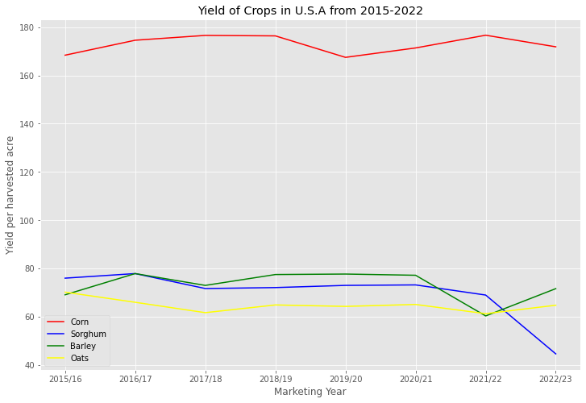

The line plot shows the Yield of Four crops planted in the United States over the last eight years. I chose line plot because it best describes the yield of the crops. From the first line plot, we can conclude that:

* Corn is the most productive crop of the four crops planted between 2015-2023 in the United State.
* Corn has a record of peaking a high yield rate for three years (2017/18, 2018/19, 2021/22).
* Corn suffered a huge drop in its yield in the United State in 2019 and this could be caused by different factors like climatic change, etc
* Corn yield might still see a drop next year if the climatic condition doesn’t become favorable as the yield for this year (2022) isn’t encouraging.
* Sorghum suffered its lowest yield in this year (2022) for the first time in 8 years,
* Barley is gaining a high trend in its yield in 2022 after experiencing a huge low last year.
* Oat is having a continuous flow of steady yield over the years.

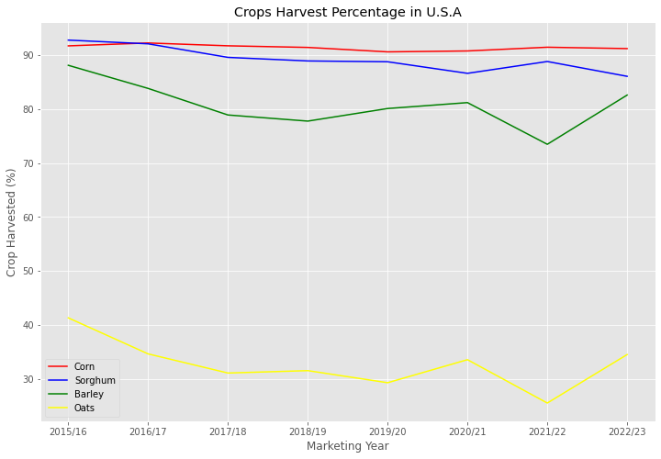

The second line plot shows the Harvest percentage of the four crops planted in the United States over the last eight years. I chose line plot because it best describes the Harvest percentage of the crops. From the first line plot, we can infer that:

* Sorghum has the highest harvest percentage over the last eight years.
* Corn has a continuous high in the percentage harvest.
* Oat is a crop that doesn’t get much harvest as it is the lowest of all four crops

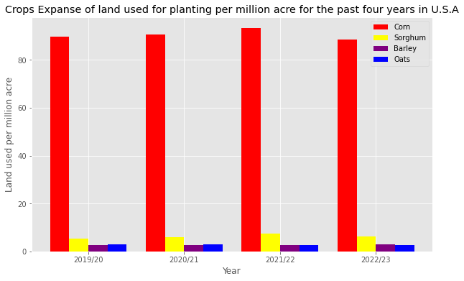

The Bar Chart shows a detailed analysis of each crop’s expanse of land usage for planting the past four years in U.S.A. I used the bar chart because it is the best to show the Land expanse used for the last four years. From the Bar Chart,

* Corn has a high land usage among the four crops, we can deduce that corn has a high consumption rate in the U.S.A compared to the other three crops. Also the number of Corn consumers increased drastically in the year 2021/22.
* Sorghum takes the second position of crop land usage of the four crops.
* Oats and Barley has the lowest land usage over the last four years. We can conclude that the number of Oats and Barley Consumers are very low in U.S.A.

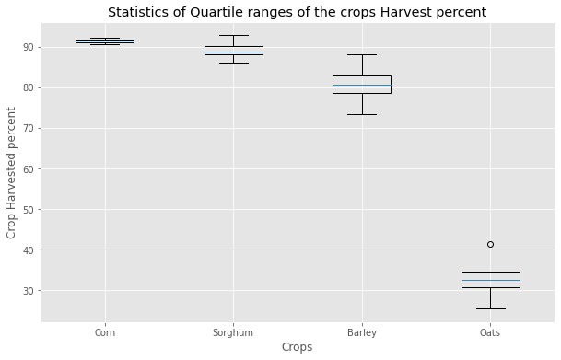

The Box plot shows a detailed analysis of each crop’s harvest percentage quartile range for the past 8 years. I used the Box plot because it is the best to show the Quartile range of values for the crops harvest percent. From the Box plot,

* There is little or no significant difference between the Upper and lower value of corn’s Harvest percent.
* Oats have an outlier far from the lower bound, which means that there is a high difference in the harvest percent of Oats over the years.

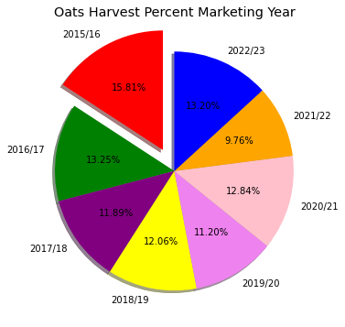

The pie chart shows Oats detailed Harvest percent for each Marketing year from 2015 to 2022. I used pie chart because it is a good use to show Harvest percent for Oats for each year. From the Pie chart, the highest harvest year for Oats was 2015/16 and the lowest harvest year was 2021/22.